1. 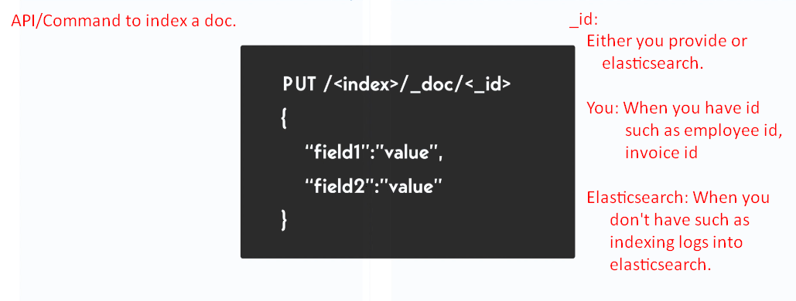  
   **Jatin**:
   1. **PUT**:
      1. Used to update already existing doc.
      2. If the doc with the specified id is not there already in elasticsearch, it will index the doc.
      3. NOTE: in PUT request, to mention id is required otherwise error.
2. 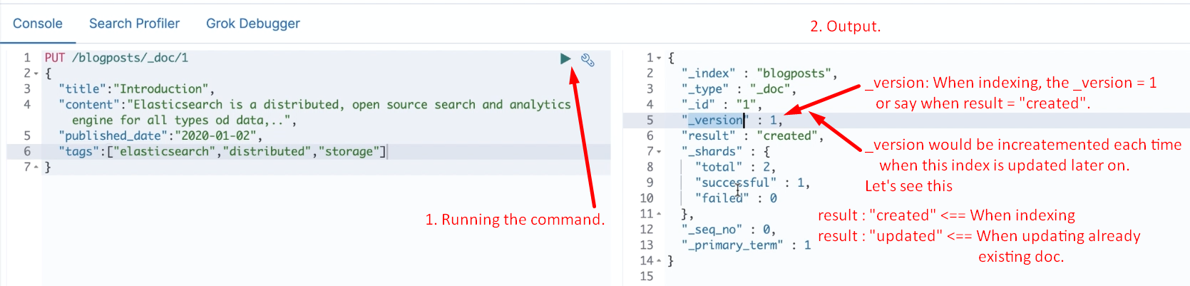
3. 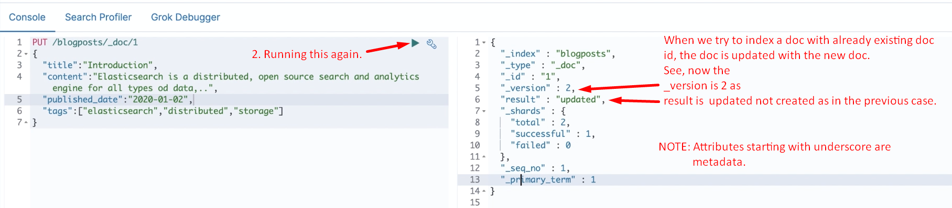

Let’s Get the Doc Back

1. **Syntax:** To get the indexed doc back.  
   
2. 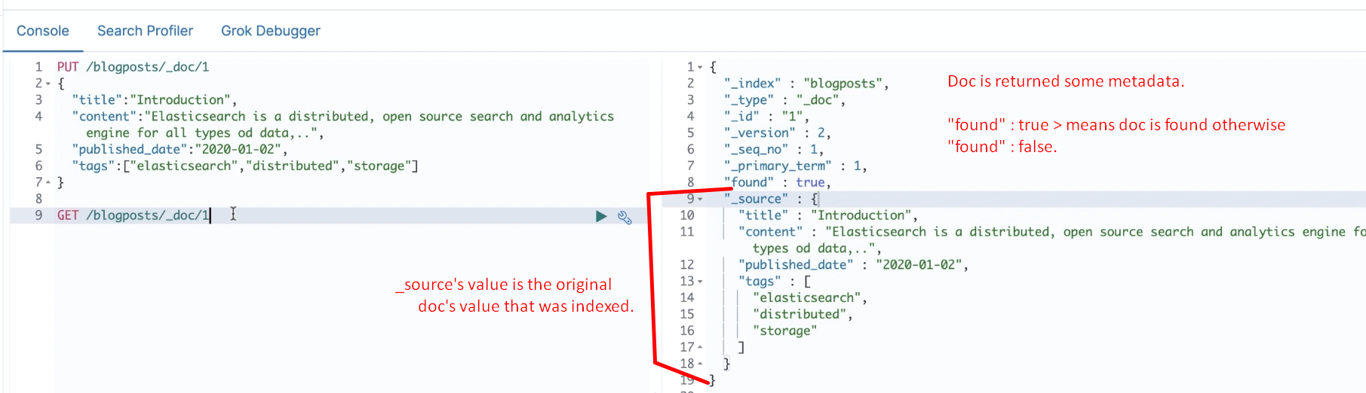
3. **CURL Command**:  
   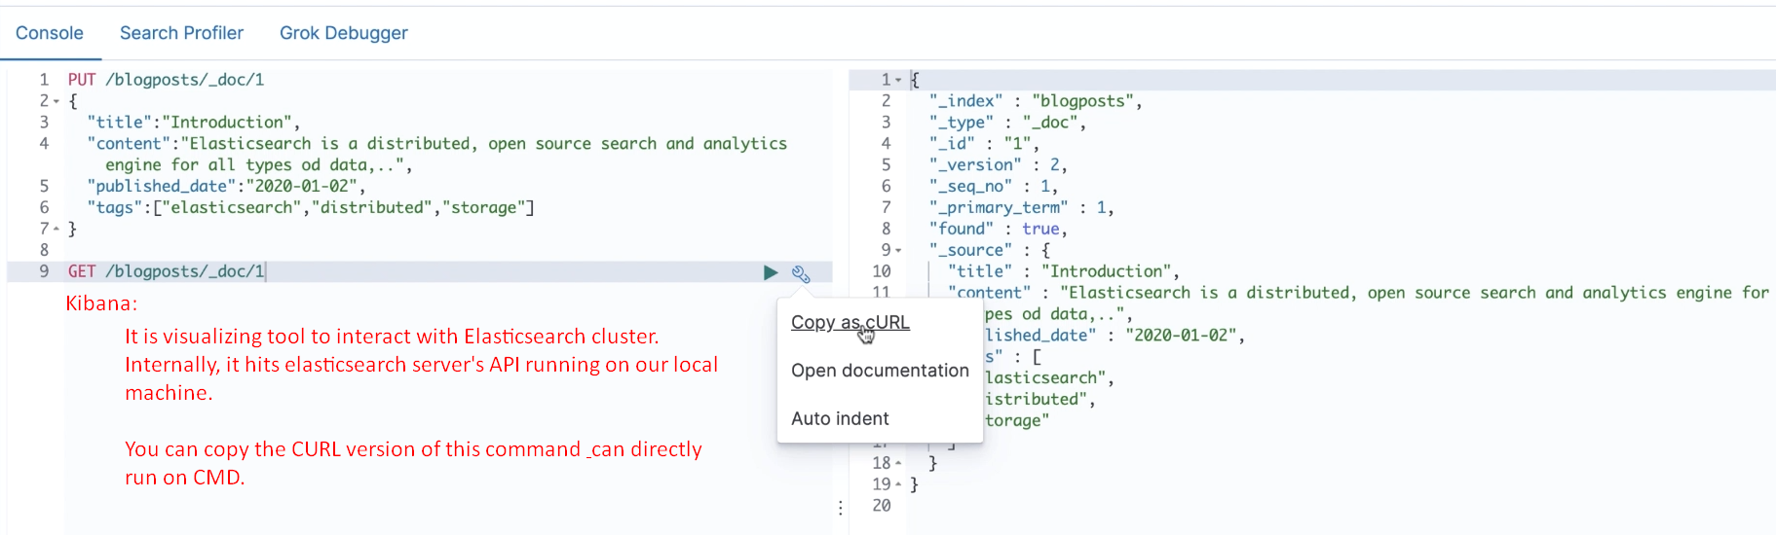
4. **Let’s open the Terminal:**
5. 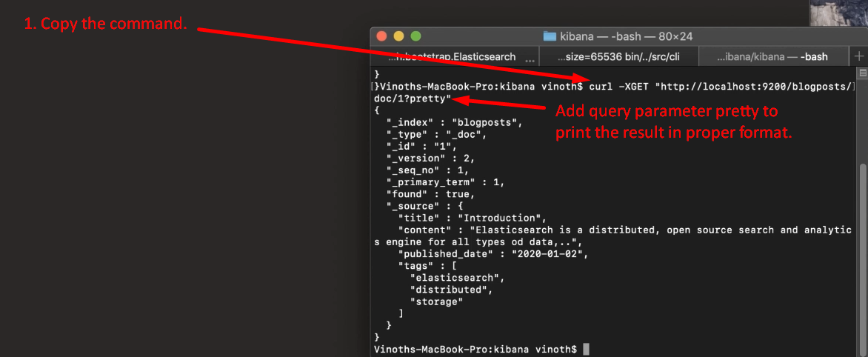

Whether Doc exists or not?

1. **Syntax**:
   1. 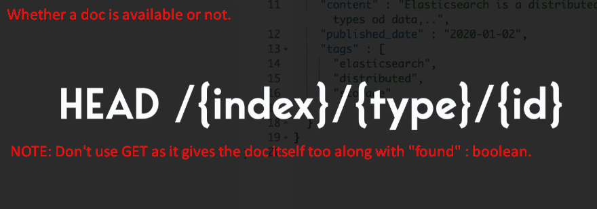
2. 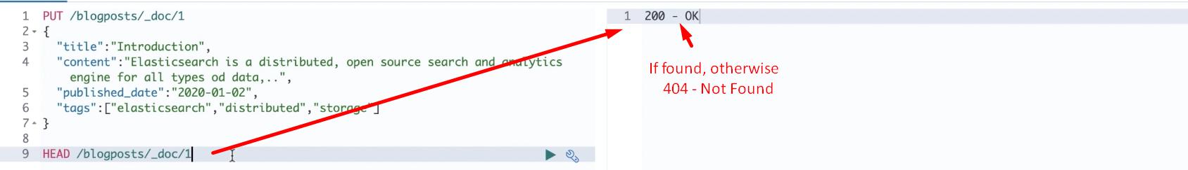
3. 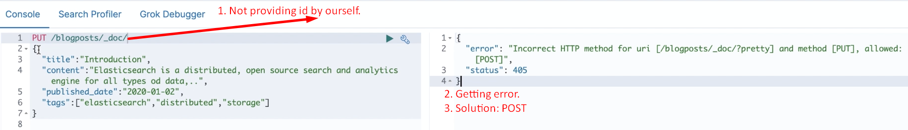
4. **Syntax**:  
   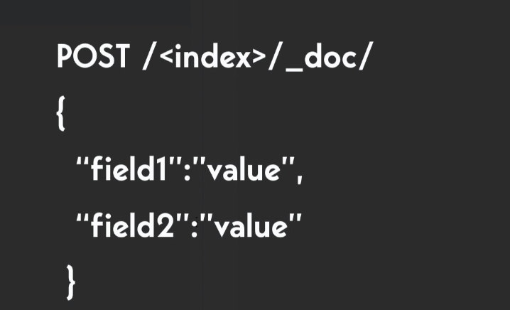
5. 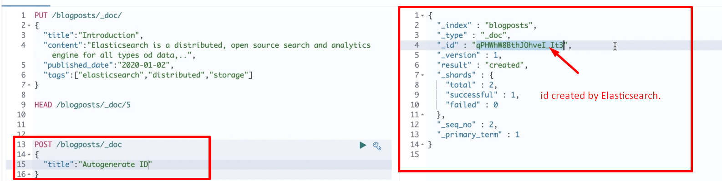

Updating a part of a Doc instead of replacing the previous doc with the new one.

1. **PUT**: This command replaces the previous existing doc with the specified id with the new one.
2. **Solution**:   
   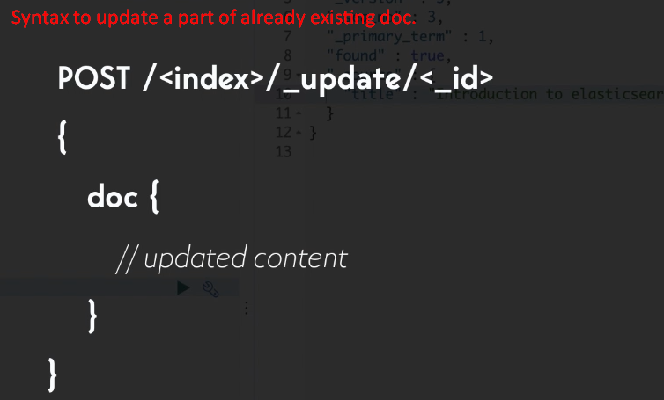
3. 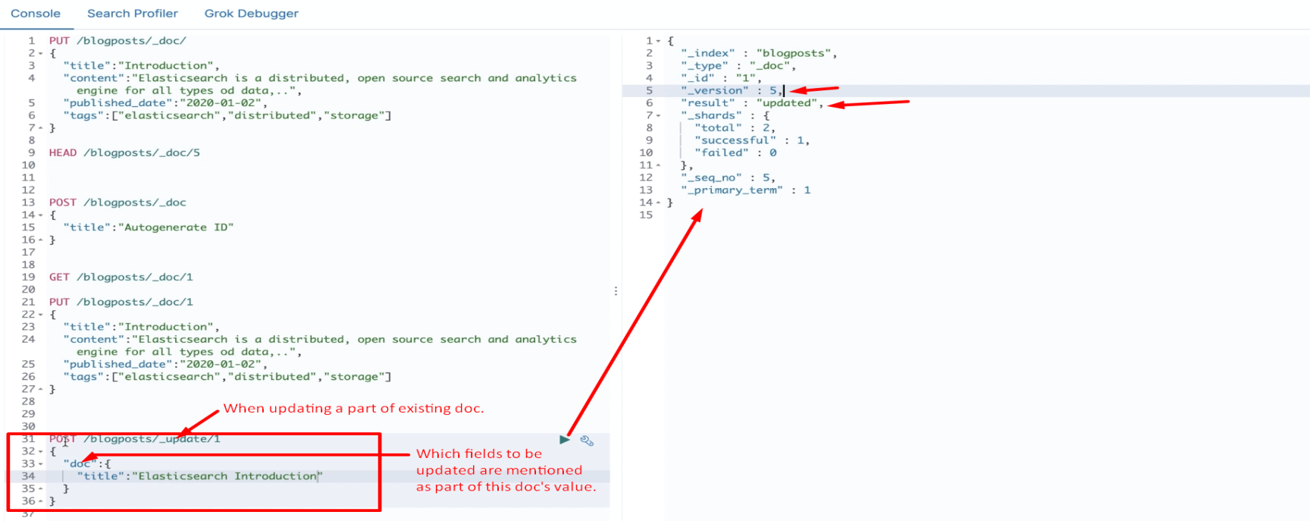
4. 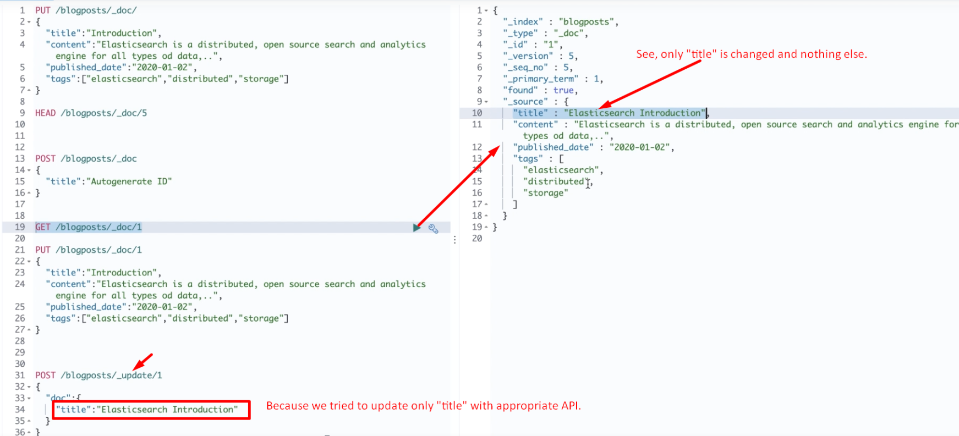
5. 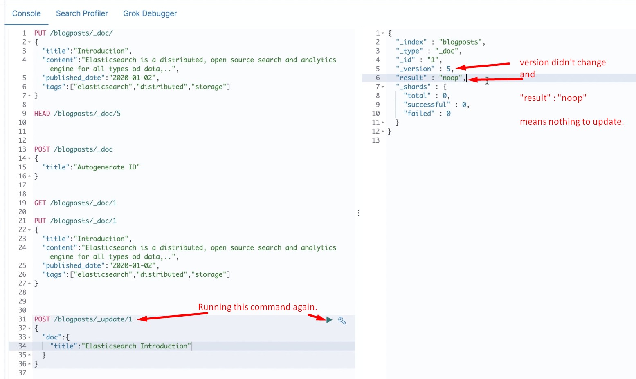
6. 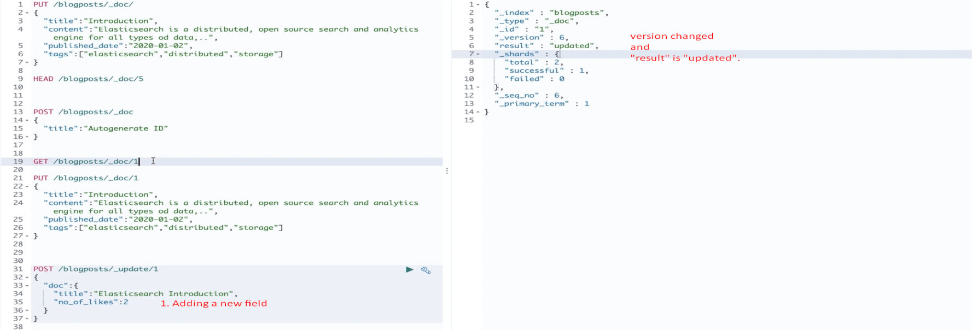
7. 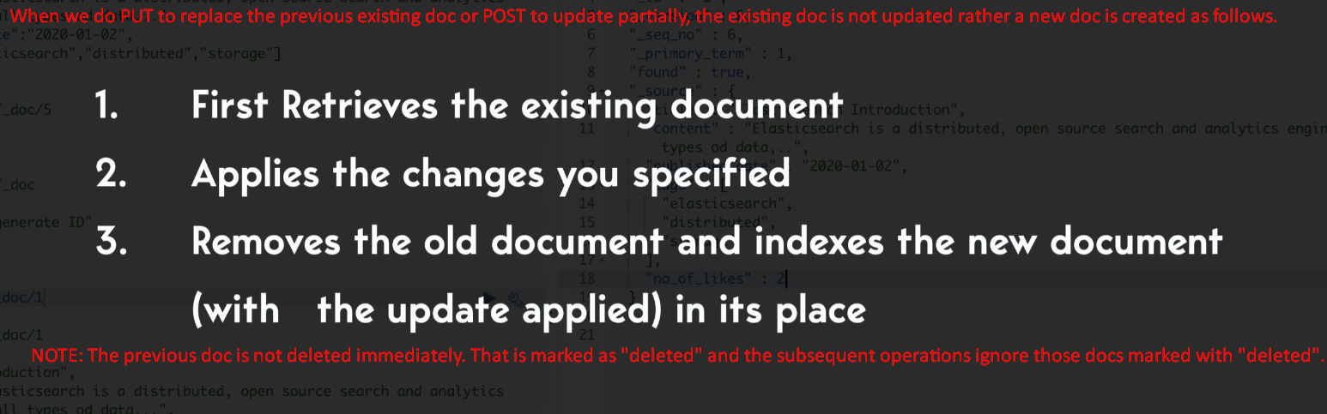

Deleting a Doc

1. **Syntax**:
   1.   
      **NOTE**: Syntax is same as that for GET except the HTTP method is DELETE.
2. 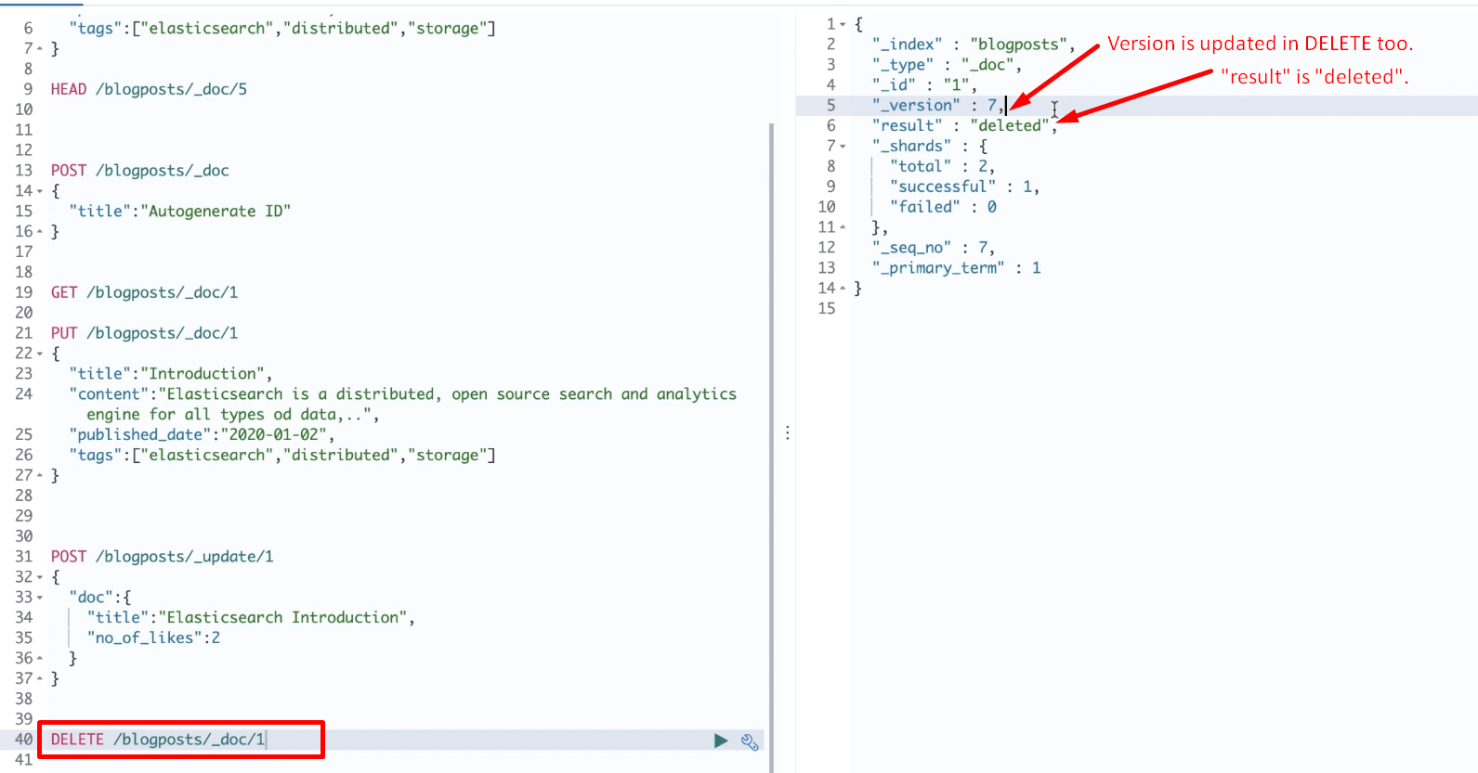
3. 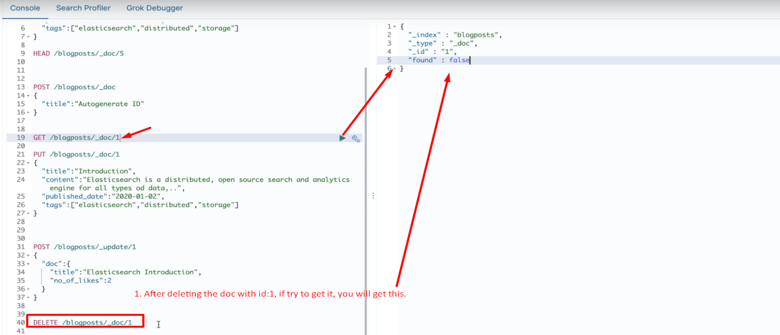

To delete index

1. 
2. 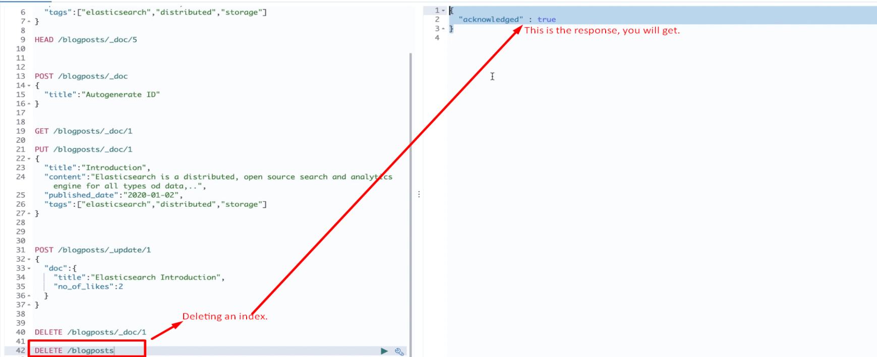
3. 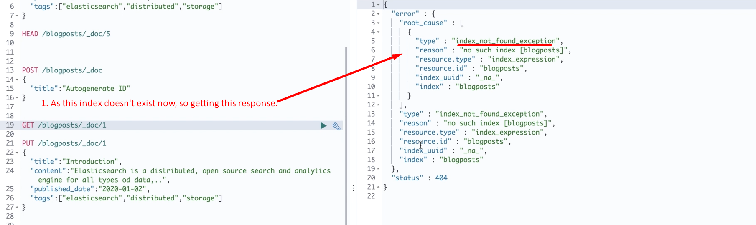

BULK API

1. So far we studied how to index, update and delete one doc at a time.
2. What if you want to do these operations on more than one doc in single API call.
3. **Solution**: BULK API.
4. **Advantage**:
   1. Good Indexing Speed.
   2. You don’t get irritated.
5. 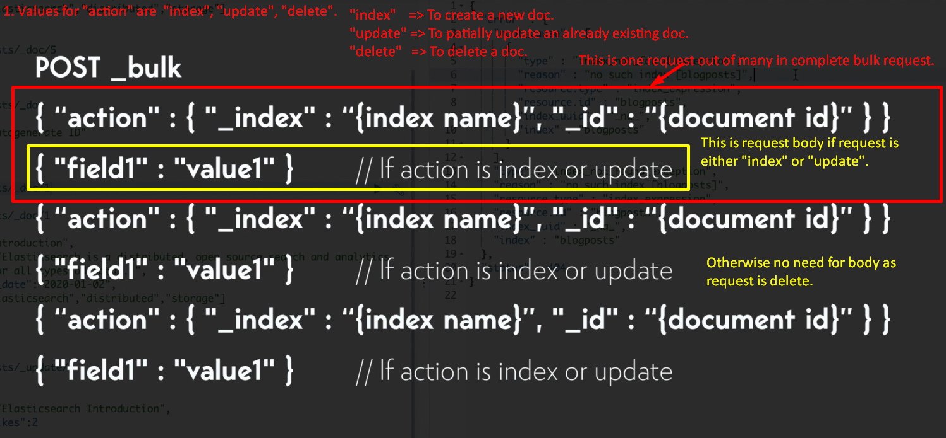
6. 